STUDIJŲ KOKYBĖS VERTINIMO CENTRAS

VILNIAUS TECHNOLOGIJŲ IR DIZAINO KOLEGIJOS
VEIKLOS VERTINIMO IŠVADOS

––––––––––––––––––––––––––––––

INSTITUTIONAL REVIEW REPORT OF
VILNIUS COLLEGE OF TECHNOLOGIES AND DESIGN

Grupės vadovas:  Team leader: | Stefan Delplace
Grupės nariai:  Team members: | Prof. Laust Joen Jakobsen
 | Prof. Roode Liias
 | Dr. Vincentas Vytis Stragys
 | Lukas Jokūbas Jakubauskas
Vertinimo sekretorius:  Review secretary: | Dr. Gillian Mary King

© | Studijų kokybės vertinimo centras
 | Centre for Quality Assessment in Higher Education
CONTENTS

I. INTRODUCTION 3
II. BACKGROUND INFORMATION ABOUT THE INSTITUTION 4
III. STRATEGIC MANAGEMENT 5
IV. ACADEMIC STUDIES AND LIFE-LONG LEARNING 13
V. RESEARCH AND ART 18
VI. IMPACT ON REGIONAL AND NATIONAL DEVELOPMENT 20
VII. GOOD PRACTICE AND ENHANCEMENT RECOMMENDATIONS 22
VIII. JUDGEMENT…………………………………………………………………………...…24
APPENDIX 1 LIST OF DOCUMENTATION PROVIDED……………………………………25

APPENDIX 2 LIST OF MEETINGS HELD……………………………………………………26
ANNEX. VILNIUS COLLEGE OF TECHNOLOGIES AND DESIGN RESPONSE TO REVIEW REPORT 27

I. INTRODUCTION

- The review of Vilnius College of Technologies and Design (referred to below as “VTDK” or “the College”) was organised by the Centre for Quality Assessment in Higher Education (SKVC), Lithuania, in its role as the Authorised Agency prescribed by Lithuanian law. The review was conducted in accordance with the prescribed methodology according to the Procedure for the External Review in Higher Education approved by Government Resolution No 1317 of 22 September, 2010.
- The College submitted a Self Evaluation Report (SER) with Annexes, and further documentation as requested by the review team. The documentation is set out in Appendix 1. The review team visited the College from 14-16 October 2014 and conducted meetings with the College, as well as touring the site. The list of meetings is set out in Appendix 2.
- The expert review team explored the four principal areas of the College’s activity as set out in the ‘Methodology for Conducting an Institutional Review in Higher Education’ (referred to below as “the Methodology”): strategic management, academic studies and life-long learning, research and/or art activities, and impact on regional and national development. Within each area of activity the review team made appropriate reference to the criteria set out in the Methodology and took due account of the lists of sub-criteria in reaching their decision.
- The external expert review team (‘the team’ or ‘the review team’) consisted of: team leader: Stefan Delplace; Prof. Laust Joen Jakobsen; Prof. Roode Liias; Dr. Vincentas Vytis Stragys (employer representative); Lukas Jokūbas Jakubauskas (student representative); review secretary: Dr Gillian Mary King.

II. BACKGROUND INFORMATION ABOUT THE INSTITUTION

- In 2008 Vilnius Technical College was merged with Vilnius College of Construction and Design to form Vilnius College of Technologies and Design, the largest technological and arts college in Lithuania. There are four Faculties in the College, housed on three sites: the Civil Engineering Faculty, the Faculty of Design, Petras Vileišis Railway Transportation Faculty, and the Technical Faculty.
- In 2013, the College provided full-time and part-time studies, the College across 21 accredited study programmes, 15 of which are technology based, 2 on social sciences and 4 on artistic studies. On 1 October 2013, the College had 3,122 students, making it the fourth largest among Lithuanian state colleges.
- The College sees its main challenges as the changes in the Law on Higher Education and Research, the establishment of competitive funding, the unfavourable demographical situation in Lithuania, increasing competition for students with other state and foreign (private) higher education schools, and increased requirements for the quality of studies.
- During the period of 2008-2013, the College received over 25 million LTL from EU Structural funds for modernization of the college infrastructure. In addition, over 6.78 million LTL of EU Structural funds were received during the same period for the renewal of the College’s study programmes and improvement of qualification of lecturers.
- The College’s mission is expressed as,
- “We train responsible specialists, members of the sustainable society in the field of engineering and design.
- We make the results of scientific research and development of technologies accessible and useful to the general public and business.”
- The College’s vision is to be
- “a Lithuanian leader in educating professional specialists in the field of engineering and design that meet European standards,
- higher education school cherishing a culture of learning organization, where lecturers and students set ambitious professional development goals, and contribute significantly to the development of a sustainable society through implementation of those goals,
- an enterpreneurial institution of knowledge that is in close cooperation with social partners and that provides professional services to businesses.”
- The College’s strategic activity is carried out under five directions: Quality, Innovation, Partnership, Entrepreneurship, and Professional organisation.

III. STRATEGIC MANAGEMENT

- As defined in the Statute the College is required to have management bodies including: College Council (referred to by the College as the College Board), Academic Council, and a Director who ‘shall be a sole management body, shall act in the name of the College and represent it’.
- The College Board was formed in 2009 and helps to define the Vision and Mission of the College and guarantee an external input to the College’s management. It discusses all aspects of the college’s activities, including finance and use of the estate and assets; appropriate use of EU structural funds; student numbers, employability and career development. The College Board is in charge of approving financial estimates, and is responsible for the election of the Director who reports to it each year.
- The Board meets not less than twice a year but meets more often if there is urgent business, and may also vote electronically, having been briefed appropriately. The Head of the Studies Office is currently a member of the Board. The team heard that it is useful to have this role-holder on the Board since he can brief the Board about the study process. The student member of the Board confirmed that the student voice is heard and listened to and can effect change. The Director is not a member of the Board but attends in an advisory capacity.
- Academic Council meets in general not less than once in 3 months. By Statute, the Director cannot be Chair of Academic Council. Academic Council provides guidance on strategic goals, relationship with industries, and so on. The Council produces initiatives for the Board to discuss and monitors the activities of the College closely. The team heard that the Academic Council co-operates closely with the College Board and that leaders of the Board and the Academic Council meet together to discuss problems.
- The Academic Council has a statutory responsibility to make proposals for the budget and it discusses financial information from the Deputy Director of Finance before deciding whether to approve budget proposals. It also approves new programmes.
- The team explored the composition of the Academic Council and noticed certain discrepancies with the way the membership was actually made up, compared to what was required in the College Statute. For example the Statute says that the number of various categories of membership should be not less/not more than a certain percentage of the total membership: representatives of student members should be no less than 20%; Associate professors/senior research staff should be not less that 20%; ex officio members (e.g. the Director) should be not more that 10%. The Statute gives no further advice on how the actual percentage should be decided. In fact, the current percentage of students representatives, 2 out of 11, is slightly less than 20%. The team heard that this number was agreed with the Students’ Union when the Statute was being formulated, and that the Students’ Union is happy with this number. However, in the interests of consistency and clarity the team recommends that the College considers revising its Statute so that it accurately describes the actual position with regard to number of different types of members of the Academic Council and is clearer about how the various members are appointed, elected or nominated to the Academic Council.
- The Director is supported by two Deputy Directors (for Academic Affairs, and Finance, respectively). The Deputy Director for Academic Affairs (DDAA) is responsible for coordination of academic activities; study process organization, development of research activities, and all other aspects of academic process. The DDAA also acts as a link with the Faculties through close contact with the Deans. At the time of the review the Deputy Director for Finance (DDF) was on leave and the role was being carried out by the Chief Accountant.
- Decision-making within the College is made by the Director in consultation with the Deputy Directors and the heads of the College’s service departments (that is, services such as Human Resources, Quality Management, Strategic Management and so on). When specific issues arise which require longer consideration the College sets up a working group which would consist of leaders of the service departments, Deans, Deputy Directors and in some cases staff of the academic Departments (lecturers, coordinators of studies, Deputy Deans, and others). One such example was a group involving the Strategic Management department and accounts personnel set up to discuss the finances related to the three-year strategic activity plan.
- Faculties initiate and draw up study programmes and develop plans for the resources required for their activities. Faculty Deans meet with the Director every week to discuss on-going issues such as buying new equipment, designing new programmes, dealing with snagging problems in new premises, etc.. All leaders of service departments attend these meetings and in this way all parts of the College are kept informed of current activities. Each Faculty has a Faculty Council; the activities of the Faculty Council are led by a Council Chair, who is elected by the Faculty Council members, by a majority of votes; the Faculty Dean makes annual report to the Faculty Council. Student members of Faculty Council have the right to vote and have powers equal to those of other members. Departments have weekly meetings to discuss problems that occur.
- Study Programme Committees (SPC) include representatives of the College’s stakeholders, students and lecturers. They are responsible for the performance of study programmes, initiating updating and encouraging the results of applied research to be included in programmes. The team considers that the active way in which students and stakeholders are included in the Study Programme Committees is good practice.
- The team discussed the relationships of the two main College bodies (Academic Council and College Board) and the relationships of their activities to the role of the Director. Initially the team found the organisational diagram provided confusing. However various members of the College provided a coherent picture of the major bodies working together to the team. This was subsequently confirmed by the social partners. The team met a number of external members during the visit and commends the commitment of the external members to the review process.
- Management of strategic planning is the responsibility of the Department of Strategic Development and the head of that Department, who is under the direct supervision of the Director, co-ordinates all aspects of strategic planning. The College uses the government-approved methodology for strategic planning.
- A SWOT analysis was carried out as part of the development of the current overall strategic plan, known as the Integrated Development Plan 2012-21 (IDP) which was approved by College Board in 2011. The IDP contains Goals, Tasks, Measures and indicators. The 5 main Strategic Directions are Quality, Innovation, Partnership, Entrepreneurship and Professional Organisation.
- Based on the IDP, three year Strategic Action Plans (SAP) are drawn up. These include the actions which have been prioritised for the coming three years. The team saw the SAP for 2012-14. For this period various priorities were allocated within the Strategic Directions and were taken forward in two programmes: ‘Programme for modernising the scientific research and study system’; and ‘Management improvement programme’. Budgets were allocated to each programme and assessment criteria and measures given to each objective.
- The review team studied the major documents concerning the Colleges’ strategic management process, including the the College’s Integrated Development Plan 2011-2021, the Strategic Activity Plan 2012-2014 and the Report on the Activities of the College Academic Year 2012-2013. The team noticed that the tasks and priorities in the SAP were slightly different from those in the IDP: the College representatives explained that long-time goals were ambitious and that changes in the environment had necessitated amendment of some of the objectives. At the moment the College is preparing the next SAP and one of the objectives which had to be deferred in the last round, the creation of an Innovation Centre, will be included again in the 2014-2016 action plan,. In this way the College makes sure that its strategic and action planning remain responsive and appropriate to change.
- The SAP 2012-2114 contains 34 key indicators. Progress of some of these indicators is reported on annually in the ‘Report on the Activities of the College’. Data on progress against all the indictors is kept in a central database and is analysed by the Strategic Management Group twice a year.
- The team considers that the Strategic Plan 2012-2014 reflects the College’s mission and values, and is in line with the strategic documents of the national policy on research and studies, and the principles of the European Higher Education Area.
- As far as the operational use and monitoring of the strategic plan is concerned the team found that there were clear processes for operationalising the strategic plan and various procedures for monitoring and reporting on it. In reviewing the indicators used in the plan the team found these to be appropriate to the purposes of the College and that progress on the achievement of indicators was reviewed regularly, reported appropriately and action taken as necessary.
- The team found that clear, concise information about the plan was made available to stakeholders and that within the institution faculty and staff referred often and appropriately to the strategic goals and understood the way the plan fed into everyday teaching, research and impact activities.
- The team heard that the College’s own Quality Assurance (QA) processes had been generated as part of an EU project. It is known as the Internal Study Quality Management System (ISQMS) and was implemented during the academic year 2012-13. As part of the project the College Quality Manual was improved, the methodology for the measurement and monitoring of College performance indices was prepared and the information system for consolidation and management of the performance indices was implemented. The team heard that as part of the project the role of Deputy Director of Quality had been removed and a Quality Department established. Faculties do not have dedicated full-time quality assurance staff and this responsibility comes within the remit of the Dean. The team heard that the QA Department works in a co-operative and collegial way with other parts of the College. Its working ethos was characterised as partnership not control and that its members were accessible and helpful.
- The QA System is based on the ISO 9001:2008 standard ‘Quality Management Systems. Requirements’; the Common Assessment Framework (CAF)/Excellence Model of the European Foundation for Quality Management; Standards and Guidelines for Quality Assurance in the European Higher Education Area (ESG); and national legal requirements. Members of the College explained why these various systems had been used and clarified their strengths for different areas of the College’s operations. It was acknowledged by the College that there could be conflicts between the different systems and that the ISO (9001: 2008) model used by the college may not be particularly appropriate for quality assurance of teaching and learning, as it has been designed for other purposes. However, the team considered that the processes being used were generally fit for purpose and effective. Members of academic staff were aware of the processes and the team considers that there is a quality culture in the College which helps to improve the College’s activities.
- Programme initiation and design starts at Study Programme Committee level and is then reported to the Faculty Council. The proposal is discussed and sent to the Academic Council. Changes to programmes may be made at Faculty level but if changes amount to more than 20% of the content it is treated as a new programme and must be approved by Academic Council. Various stakeholder opinions are taken into account in amending and designing programmes: the team heard examples from students, employers, social and academic partners about how they had had input to programme design.
- Monitoring of programmes takes place at the weekly meetings of Deputy Directors, leaders of service departments and Deans. Here problems with programmes, for example, drop-out rates, are discussed and can be compared across Faculties. Minutes of these meetings inform the QA Department of on-going problems and they can prepare an improvement plan for the next academic year if need be.
- The team heard in a meeting with students that they are required to fill out evaluation surveys on the teaching they had received. Students considered that surveys were not always filled out in a meaningful way by their peers. Nevertheless, they considered that changes were made in response to the evaluations and gave some examples of this. Students felt that responses were also made in response to the opinion of the Students’ Council but they did not always get regular feedback from the students’ representatives.
- The College regards external scrutiny and evaluation in a positive light and regards them as a way of improvement. The team was aware that 10 of the College’s programmes had been evaluated by an external agency, and that the College had been reviewed in 2007 by SKVC. One of the recommendations of that review was to “adapt College‘s Quality Manual for the needs of the College‘s activity”. The team heard that the College had updated the manual, bearing in mind the actual use which College personnel needed to make of it. The team reviewed the Manual (available in Lithuanian only) and found it to be comprehensive and clear. The team recommends that the Manual is made accessible to all staff by making it available through the College intranet.
- The team heard of numerous changes to structure, operations and study programmes – some very significant – since 2008. For example two departments were integrated into the single Railway Infrastructure and Informational Systems Department; a further two departments were merged to become the Media Department; the Department of Applied Research Activities and the Internal Audit Service were established; a new internal quality management system was introduced; study programmes were updated and in some cases radically changed. The team considers that these and other changes have been appropriate to the College’s mission and goals and have impacted positively on all aspects of the College’s activities.
- Decision-making, distribution of responsibilities and accountabilities, and the allocation of resources appeared to the team to be operating effectively in the College. The team heard various instances of external stakeholder input to decision-making. The breakdown of responsibilities between top management and College bodies was working appropriately.
- The review team heard details of staff recruitment processes, incentive schemes, and possibilities of professional development and upgrading of qualifications. The team was told that each position in the College had specific criteria attached to it, and that in the future the ability to speak English would also be included. The annual workload of a full time lecturer is 1548 hours. The workload is divided into teaching and organizational activities, applied research, art activities, and preparation of teaching resources. When planning lecturers’ activities attention is paid to the strategic aims of the College. Within those boundaries the lecturer then plans his or her own activities.
- The team heard that the responsibility for professional development lay with the individual staff member and that requests would be discussed with the Director and passed on to the Personnel Department. Staff could request leave to update their qualifications and the College would make arrangements to cover the teaching of the teacher while he or she was away. The team heard from the College that the academic freedom enshrined in the College statute was evident in the College. Staff were free to change study courses according to student need and to choose their teaching methods. The team considered that the College took seriously the management of human resources.
- The Audit Department, is under the supervision of the Director and reports directly to the Ministry of Finance. It carries out internal audit and reports on the transparent and efficient use of resources and finances. It audits various College functions, not only finance. It provides recommendations for the improvement of management, including management of risk. The team heard that the Department looks at risk one year at a time and that there is no separate risk management plan. However, the Finance Office takes a longer term planning horizon and tries to look ahead over the three period of the SAP. This is in order to decide, for example, whether, based on the projected student numbers, project funding would be necessary. While the team acknowledges that there is analysis of short-term risk, it recommends that the College considers implementing a more systematic, frequent and long term system of risk management.
- During its tour of the premises the team saw many instances of how EU project funding and sponsor donations had has a positive impact on the learning resources. Many of the facilities for study which the team saw were excellent; some, such as the blue screen photographic studio were better equipped that the local industry. Industry standard software packages were in use. The team commends the College on its effective management of EU projects and the positive impact that has been made on study processes. The team also encourages the College to continue with its renewal and refurbishment activities to bring the rest of the premises up to the same standard.
- The team saw examples of cross-faculty initiatives such as the design and building of a racing car. Both Design and Technology students had participated in the project (see paragraph 75). The team heard from students that they were free to use laboratories outside of class time, but not at night. They mentioned that VTDK hackLAB was a particularly useful resource. This is a laboratory space where students can experiment with designing, adapting and improving software and hardware. Moreover this lab is also open in the evenings, thanks to staff who then voluntarily supervise the work of the students after class hours.
- The library subscribes to various databases and students told the team that they got an introductory lecture on how to use the databases. However, use is somewhat limited since most of the publications are in English.
- The team concludes that the College’s teachers are enthusiastic and committed to their role and that management of learning resources is effective.
- The College’s main sources of funding are state income, which is dependent on the number of state students admitted, and EU structural and project funding. The team heard that the College could use its own earned income as it wished and that it did not have to be spent in the year in which it was earned. The College had created a reserve using such funds.
- Almost all of the extensive renovation of premises which has happened recently was financed by EU structural funds. The team explored what would happen to project activities when project funding ceased. The College indicated that would find funding from its own finances if necessary, and that some projects were restructuring rather than investment in additional personnel or facilities. These, therefore, would continue on the underlying College funding once the project funding period had finished.
- The team heard that Faculties do not have complete financial autonomy. Funding was allocated to Faculties according to their needs. While Deans could change allocations within the Faculty allocation, they could not exceed it. However, Faculty income was attributed to the Faculty that earned it. The team heard that Deans of Faculties participate in working groups to discuss budget allocation and that the discussions were rigorous. The starting point for allocation of funds were the College’s strategic goals and priorities.
- The Public Procurement Department (PPD) advises on purchases of services and goods, and discussion on spending would take place between the PPD and relevant service departments and academic personnel as required.
- The team considered whether the College’s use of its funds to support its purposes was reasonable and found that at present it is. However, the team found no evidence of medium-long term budget and investment planning in the budget provided in Annex 5 of the SER . For example, there was no obvious planning for rising infrastructure maintenance costs, rising utility costs, or how a decrease in EU funding would be compensated for. It was also not obvious to the team how medium-to-long term projections of student numbers were used in budgeting. The team was told that after the recent infrastructure modernisation 4500 students could be accommodated, compared with the 3328 currently studying. It was not clear to the team whether the College was planning to increase student numbers on this scale in the medium-to-long term, nor what budgetary repercussions this might have. In view of this, the team recommends that the College reviews its processes for budget and investment planning and puts processes for medium-long term planning in place.
- The team heard from staff and students that there are policies and processes for dealing with academic misconduct by staff and students. There is a code of ethics for staff which they must read when they are recruited and sign to say that it has been read. Students have their own code of ethics and the team heard that the Student Council had input into a proposed new Code of Ethics which would be produced in the near future. The College explained various ways in which it tried to prevent student misconduct. For example, when students are drafting their final thesis they must sign a declaration of authorship, and if it suspected that a project is not original it is checked using an internet programme. The College indicated that no cases of misconduct had been dealt with so far under formal procedures.
- In summary, the team found that the College’s management was largely fit for purpose and effective. The team found the quality culture in the College to be a feature of good practice, as was the effective management of EU projects and the positive impact that these had made on study processes. The commitment of external members of the Board and stakeholders to the review process is to be commended. Areas for development include: revising the College Statute so that it reflects the actual position with regard to membership of the Academic Council; implementing a more systematic, frequent and long-term system of risk management; and reviewing budget and investment planning processes.
Strategic Management of the College is given a positive evaluation.

IV. ACADEMIC STUDIES AND LIFE-LONG LEARNING

- During their discussions and from reviewing the documents provided the team considered that the study programmes and lifelong learning provision of the College reflect the College’s mission and strategic documents, and also meet the needs of the national economy and social and cultural development. A good example of how this is achieved is the design of the Multimedia Design study programme. This was initiated by teachers and students who considered that the existing programme needed modernising. Erasmus students fed in ideas for revision, as did teachers who had links in Europe. The market was researched and it was agreed that the new programme was needed in Lithuania.
- The external review of 2007 recommended that the College “establish the Centre of Distance Learning in the College”. The College’s 2014 SER explains that the nature of the College’s programmes require the physical presence of students in the College to carry out practical tasks. This made the setting up a Centre for Distance Learning inappropriate to the College’s mission and objectives and the recommendation was not followed up specifically. However, elements of online learning have been embedded in the study process. The College uses Moodle as a Virtual Learning Environment (VLE) and the team heard that this enabled students to work remotely and keep in contact with teachers. Furthermore, one of the objectives of the SAP 2012-14 is to develop IT applications in the study process, and there is an indicator for the percentage of lecturers who post course materials on the intranet. For 2014 the College is aiming at 90%. Another indicator used is the percentage of subjects in a study programme to be delivered by elements of distant learning. The annual target (achieved in 2012-13) is not less than 20%.
- There is a good variety of lifelong learning provision, designed directly with the needs of stakeholders and partners in mind. However, the team considers that the College could meet national needs even better in the specialised fields that it offers by diversifying the lifelong learning that it provides. The team recommends that the College be more proactive in offering the kinds of part-time vocational courses that they currently offer on demand.
- The team heard that students with special needs were treated comparably to other students within the College. The team heard the case of deaf students who attended lectures with interpreters and who, after the lectures, had the opportunity to clarify them with the lecturer. The team heard that every lecturer had hours to spend with students who needed support in particular subjects, for example, maths.
- The team heard that some of the College’s programmes were not particularly accessible to students with some disabilities because of the physical nature of some of the tasks that needed to be carried out. However, there were students with special needs in the Design Faculty. In the Design and Technical faculties building all entrances are accessible and there are dedicated lifts for wheelchair users.
- The team heard that the College supported specially gifted and talented students by organising lecturer-student partnerships; encouraging them to participate in projects, competitions and Erasmus exchanges; and linking bright students together for joint activities such as visiting fairs.
- The College validates prior learning from students from other HEIs who provide certificates and descriptions of their studies. The relevant Head of Department validates that the Learning Outcomes are relevant and appropriate.
- The College maintains good contact with graduates and alumni through a variety of means and thus has a good idea of the employment positions of its graduates. The SER describes a formal system of surveying the employment of graduates. The team heard in a meeting with graduates and alumni that the College’s programmes had prepared them well for their subsequent jobs. They received a good foundation of knowledge and practical skills. Practice placements in various companies were appreciated. A part-time student noted that the theoretical background he received while studying could be fed immediately into his work situation.
- The alumni who are now employers noted that graduates of the College require less on-the-job training than other graduates, and were able to rise to leadership positions. The team considers the practice-based preparation which students receive in the College through their study programmes to enable them to become effective employees is a feature of good practice.
- Despite good employability figures, the College acknowledged that the level of student drop-out was a concern and that all members of the College were involved in trying to improve the situation. The College knew from its data that the biggest drop-out rate was in the first year and the College considered that this could be due to a lack of preparedness on the part of high school students for work at higher education level. The College had put in place a first year test to identify weaker students, counselling activities, and a guide for teachers on how to help students. The College also suggested that the use of Moodle as a Virtual Learning Environment was helping to cut down drop out rates because students could work anywhere, have easy access to study tasks, and teachers could keep in regular contact.
- The team heard that teachers in the Design Faculty considered that there were specific reasons for student drop-out: many students came with a false expectation that Design subjects were ‘soft’ subjects, more about art than design. On the other hand, some students did not have the necessary artistic talent to be successful. Teachers felt that the positive side to such students leaving the programme was that they could go on to explore career routes that were more appropriate for them. Generally the team found there was adequate student guidance in place on the Central and Faculty level. This also transpired from the discussions with the students and alumni.
- The College knew that the drop-out rate was greater for students who funded themselves, and thought that this could be because state funding went to the better qualified students who were more likely to succeed. The College was considering defining the score below which students could not enter its programmes. It considered that this could be a risky development since it could reduce student numbers, but it might improve quality.
- The team heard from alumni that they were involved in College activities in a variety of ways: giving feedback on programmes, giving lectures and workshops, at the Diploma defence. The feedback that the College receives through its contact with alumni and graduates, together with student evaluations and feedback, is used to good effect in improving study programmes and feeding into applied research.
- The team heard that social, academic and business partners are involved in numerous ways in the College’s activities: sitting on the College Board; providing practice opportunities for students; providing feedback on study programmes; in Diploma defence committees; in employing graduates both as mid-level professionals and skilled labourers; in providing internships for staff; exchange of information about the market and skills needs; sending their own employees for in-service training; equipping laboratories. Such feedback had encouraged the College, for example, to increase the practical components of programmes, and relocate a faculty. The team considers that the good relationships with partners impacts in a very positive way on the quality of studies. The team considers the way the College encourages the active involvement of partners in all spheres of College life and the effective use made of their contributions to be good practice.
- The team considered how well the study programmes and lifelong learning met the provisions of the European Higher Education Area and the EU documents relating to higher education. The team found that there was a good understanding of these requirements by the College leadership and found the mapping of developments in the SER (Table 14) a useful record. Study programme descriptions indicated study requirements in ECTS and Diploma Supplements are provided. Staff were clear about the level, both on the EQF and the Lithuanian QF, at which programmes were located. They were also clear about where the boundaries of their power as a College of Higher Education in the Lithuanian legal framework lay when it came to offering programmes at other levels (such as formal vocational education). As noted above, one of the bases for the College’s ISQMS, is the European Standards and Guidelines for Quality Assurance.
- The team heard positive experiences of mobility programmes from students and staff. The College indicated that it would like to have more students and lecturers go abroad but that there were financial restrictions. The College indicated that lecturers encourage students to take part in Erasmus activities and that the students who took part were very satisfied with the experience and were great ambassadors for the activity. The College organises meetings with students so that those who have taken part in mobility programmes can pass on their experience, and organises competitions by which staff and students can apply to participate in mobility activities. Students whom the team met confirmed that the College strongly encouraged students to take part in mobility projects, as did the students who had taken part.
- The team heard that the Students’ Union has a representative who is in charge of counselling/mentoring incoming mobility students. The team considered that the College’s English language website was not as useful for incoming students as it might be (for example, information about course study schedules was not available) and heard that it was under development at present.
- The team noted that international mobility figures for both student and staff had increased in recent years but that they were still somewhat low. During 2008-2014 there were 358 outgoing students and 122 outgoing lecturers, 182 incoming students and 155 incoming lecturers as part of various international initiatives, but mainly as part of ERASMUS. Between 2008 and 2014 staff mobility (incoming and outgoing) increased from 39 to 44. In the same period the number of students taking part in mobility programs rose from 29 to 74. The team heard that the College would like more staff and students to go abroad but that there were financial barriers to this. In the meeting with students the team heard of some of the barriers to students going abroad: for example, the perception that they could be going to a country where they would be discriminated against as a foreign national, or the language barriers, or the lack of time. The team recommends that the College gives attention to whether these barriers can be overcome to increase student mobility. The team appreciates that this may be a national, rather than a purely College, issue and recommends that the Ministry gives consideration to finding ways to encourage students to participate in mobility programmes.
- In summary, the team found that the College’s study programmes and lifelong learning were appropriate to its mission and to regional/national priorities, and reflected the principles of the European Higher Education Area. Input from various stakeholders, including students, was taken into account in improving study programmes and lifelong learning. The team considered the College’s preparation of students for employment, and the way it encourages the active involvement of partners in all spheres of College life to be features of good practice. Areas for development include: to be more proactive in offering the kinds of part-time vocational courses that the College currently offers on demand; and giving attention to the barriers to mobility which students identify to see whether these can be overcome. The team also recommends that the Ministry explores this same issue on a national level.

Academic studies and lifelong learning in the College is given a positive evaluation.

V. RESEARCH AND (OR) ART

- During the period analysed for the self assessment, 25 articles were published by staff of the College and included in the database of the Institute for Scientific Information (ISI). In addition 20 articles were included into the other databases, 127 articles were published in the proceedings of foreign and Lithuanian conferences, and 192 presentations were made at international and national conferences. Lecturers of the College presented pieces of art at 26 international exhibitions, and 65 exhibitions in Lithuania were attended. Films, soundtracks for television, plays, concerts, and festivals were produced, and interiors were designed for Lithuanian clients.
- The review team found that the College’s applied research agenda reflects the strategic documents, and aligns with the needs of regional economic, cultural and social development. For example, staff were engaged in research projects varying from developing a model for improving work organisation in construction companies to preparing a model of the Earth’s vertical crust movements. Students and lecturers also contributed through art and design projects: for example, participating in the Vilnius culture and art festival “Kultūros naktis” by organising creative workshops, interactive video and sound installations; and designing stained-glass works for the Vilnius Lower Castle in the complex of the Palace of the Grand Dukes.
- Various research projects at the College are carried out with academic, social and business partners. One example given was co-operation with VGTU on analysing the ecological and economic effects of using hydrogen for gas-driven buses.
- There is good co-operation between the Design Faculty and the ‘technical’ faculties. In fact, one alumnus having experienced this co-operation in his studies regretted the lack of it in his work situation. One particular example of cross faculty co-operation that the team heard was the construction of the racing car mentioned above (paragaph 43). Students from the Technical Faculty had been involved in the design and manufacturing of the vehicle and Design students had produced a logo, external styling, designs for racing clothing, and so on.
- Students are involved in applied research projects and the results are incorporated into their final theses. Study Programme leaders are responsible for ensuring that results of applied research are built into study programmes. In the Design Faculty the creative experience of teachers is applied to the teaching process and is used to formulate tasks for students.
- The team explored the College’s strategy for capacity building in research and heard that the College encouraged lecturers to study for PhDs and relied on lecturers being proactive in suggesting ideas for research projects. The College also invites qualified outsiders to undertake research in the College. The College acknowledged that not every lecturer could be a researcher. It was explained that when Deans allocated the workload for the coming year those who were more active in research were allocated fewer teaching hours.
- During its discussions with staff the team heard that different staff defined their activities in different ways: some as applied research, others as experimental development. However, there was agreement that the College did not carry out ‘fundamental’ research which was the task of universities. The team considers that it would benefit the College to think more clearly about how it defines applied research and recommends that it draws up a strategy for applied research which would help to target the most relevant activities and allow evaluation of effectiveness. The Strategy should pay attention to how the College could build up the capacity in researchers. It would also be beneficial for the College to consider more carefully how applied research impacts on study programme quality in a systematic and coherent way.
- The College takes part in various international activities. It organises international conferences, and has close connections with some foreign academic, business and social partners. However, the College indicated that it saw joining international research networks as a challenge and was trying to improve this. The team concurs that so far the College does not take full advantage of the international networks to which it belongs. Using such networks more effectively could help the College to address the recommendations made above on international mobility (paragraph 70).
- In summary, the team found that the College carried out a variety of applied research and art activities, co-operating with stakeholders and involving students in the activities. The team found the cross-Faculty initiatives to be a feature of good practice. Areas for development include drawing up a strategy for applied research, considering how the College could build up capacity for research, and how it could more systematically build applied research results into the study process. The College should also consider how it could use its international networks more fully, especially to increase international mobility in the College.

Research and art activities in the College is given a positive evaluation.

VI. IMPACT ON REGIONAL AND NATIONAL DEVELOPMENT

- The College currently has 145 agreements in place with various partners. The team heard numerous examples of the College’s impact on regional and national development in the economic, cultural, social and environmental spheres. Projects chosen by the College complied with national and regional needs. For example, co-operation with Toyota to teach automobile technology; teaching of traffic management, which is unique in the Baltic states; the College has flexible study conditions for students who are in voluntary military service.
- The College maintains active links with other education sectors and levels of education, from high schools and vocational schools to research universities.
- The College’s graduates play a distinct role in regional industry, infrastructure and commerce, and development of art and design, and are successful in finding jobs in the region. In this way the College’s impact on regional development is convincingly demonstrated.
- Various themes relating to regional and national development are included in students’ training practice and graduation projects: e.g. graduation papers include ‘Preparation of the land management project for the land reform in Magūnai cadastral location of Švenčioniai district’ and ‘Information system for the preparation of freight shipment documents’. Art and design projects contributing to the cultural environment included ‘Visual style for the TV programme “The Key”’ and the DVD ‘Manor Houses of Lithuania’. Student social project titles included ‘Basics of Economic Driving’ and ‘Social Support for Seniors’. Both staff and students were enthusiastic about such work and students appreciated the experience that they gained from these projects.
- The team heard of various involvement by students and staff in voluntary activity, professional bodies and other national associations. Professional associations included Association of Educators and Teachers of Motor Vehicle Transport, Association of Mentors of Part-time Studies at the Colleges, Lithuanian Association of Graphic Design, Energy and Environment Protection Sectoral Professional Committee, Society of the Physically Disabled of Lithuania, and Lithuanian Association of Libraries of Colleges.
- Participation in organisations not directly connected with professional activities included membership of Lithuanian Union of Travellers; Forum of Lithuanian Parents, and Lithuanian Union of Folk Artists. The team also heard of a project in which students and staff cleaned up the local environment, of recycling events, and competitions based on ecological themes. The College makes its buildings available to other users in the community. During the visit the team encountered a party of schoolchildren from a local school who had used the College gym; they also use the canteen at lunchtime.
- In summary, the College is involved a large variety of projects and activities which impact the local, regional and national areas. Social partners and stakeholders testified to the excellent reputation which the College has in the region and were complimentary about the work of the College in producing well qualified graduates which met the needs of the region. Various unique or distinctive features of the College were pointed out: the level of practical work involved in the programmes; their track history in producing successful middle-level professionals for various industries; the degree of specialisation in some programmes. Despite the significant changes over the last decade the picture given was one of a College which strives for excellence and has improved on its strong position in the sectors in which it operates.

The College’s impact on national and regional development is given a positive evaluation.

VII. GOOD PRACTICE AND ENHANCEMENT RECOMMENDATIONS

- The team identified the following features of good practice:
- The active way in which students and stakeholders are included in the Study Programme Committees.
- The quality culture in the College which helps to improve the College’s activities.)
- The College’s effective management of EU projects and the positive impact that has been made on study processes.
- The practice-based preparation which students receive in the College through their study programmes to enable them to become effective employees.)
- The encouragement that the College gives to partners to be involved in all aspects of College life and the effective use made of their contributions.
- The good co-operation between the Design Faculty and the ‘technical’ faculties.

- The team identified the following recommendations:
- The team recommends that the College considers revising its Statute so that it accurately describes the actual position with regard to number of different types of members of the Academic Council and is clearer about how the various members are appointed, elected or nominated to the Academic Council.
- The team recommends that the Quality Manual is made accessible to all staff by making it available through the College intranet.
- The team recommends that the College considers implementing a more systematic, frequent and long term system of risk management.
- The team recommends that the College reviews its processes for budget and investment planning and puts processes for medium-long term planning in place.
- The team recommends that the College be more proactive in offering the kinds of part-time vocational courses that it currently offers on demand.
- The team recommends that the College gives attention to whether barriers to student mobility can be overcome to increase mobility.
- The team recommends that the Ministry gives consideration to finding ways to encourage students to participate in mobility programmes.
- The team recommends that the College draws up a strategy for applied research which would target the most relevant activities and allow evaluation of effectiveness. The Strategy should pay attention to how the College could build up the capacity in researchers.
- The team recommends that the College consider more carefully how applied research could impact on study programme quality in a systematic and coherent way.

VIII. JUDGEMENT

Vilnius College of Technologies and Design is given positive evaluation

Grupės vadovas:  Team leader: | Stefan Delplace
Grupės nariai:  Team members: | Prof. Laust Joen Jakobsen
 | Prof. Roode Liias
 | Dr. Vincentas Vytis Stragys
 | Lukas Jokūbas Jakubauskas
Vertinimo sekretorius:  Review secretary: | Dr. Gillian Mary King

APPENDIX 1 LIST OF DOCUMENTATION PROVIDED

- Self Evaluation Report of Vilnius College of Technologies and Design for the period of 2008-2013
- SER Annex No. 1 College organization scheme
- SER Annex No. 1a Involvement of concerned parties into the processes
- SER Annex No. 2 Strategic activity plan for the years 2012-2014
- SER Annex No. 3 Statute of Vilnius College of Technologies and Design
- SER Annex No. 4 Report on the activities of the college academic year 2012/2013
- SER Annex No. 5 Revenues and expenses during the last 6 years
- SER Annex No. 6 Project „Improvement of internal study quality ensuring system of Vilnius University of Applied Engineering Sciences“ VP1-2.1-ŠMM-04-K-02-011
- SER Annex No. 7 List of study programmes
- SER Annex No. 8 Number of students in study programmes
- SER Annex No. 9 List of the main (the most important) applied research activities
- SER Annex No. 10 Statistics on the degree, establishments, positions of the College lecturers/researches /scientists during the assessment period
- SER Annex No. 11 List of the most important researches, projects and other activities related to regional development
- SER Annex No. 12 SWOT analysis
- SER Annex No. 13 Internal study quality management system (ISQMS) of the College
- SER Annex No. 14 Practical application of the Standards and Guidelines for Quality Assurance in the European Higher Education area (ESG) at the College
- SER Annex No. 15 Assessment of ISQMS areas, evaluation procedures
- SER Annex No. 16 Study programmes updated while implementing ES Structural Funds projects
- SER Annex No. 17 Delivery of formal and non-formal vocational training programmes
- SER Annex No. 18 Most significant graduation papers which results have practical applicability
- SER Annex No. 19 Projects implemented in the VTDK.hackLAB laboratory
- SER Annex No. 20 Examples of most significant social projects implemented by students
- SER Annex No. 21 Inclusion of topics relevant for the regions and development of the whole county into student practices and graduation papers by study field
- SER Annex No. 22 Activity of VCTD academic and administration personnel
- Development of the applications of innovative teaching
- Female and male ration in the College
- Students dropout rate 2008-2013
- SER Table 10 (revised)
- Integrated Development Plan (in Lithuanian)
- Examples of final year theses (in Lithuanian)
- Samples of College Board and Academic Council Meetings Minutes (in Lithuanian)
- Samples of subjects/modules descriptions (in Lithuanian)
- Samples of feedback from students and other stakeholders (in Lithuanian)
- Quality Manual 2014 (in Lithuanian)

APPENDIX 2 LIST OF MEETINGS HELD

 | 14 October 2014, Tuesday
9.00 – 9.30 | Meeting with Director
9.45 – 10.15 | Meeting with Deputy Directors
10.30 – 11.30 | Meeting with the Deans of Faculties and Directors of some Study Programmes
11.45 – 12.45 | Meeting with Self – evaluation group members and representatives of Quality Department
13.45 – 14.45 | Meeting with Academic Council representatives
15.00 – 16.00 | Meeting with College Board members
 | 15 October 2014, Wednesday
8.30 – 9.30 | Meeting about strategic management
9.45 – 10.45 | Meeting about academic studies and life-long learning
11.00 – 12.00 | Meeting about applied research and/or art activities
12.15 – 13.15 | Meeting about impact on regional and national development
14.15 – 15.15 | Meeting with students and Students’ Union representatives
15.30 – 16.15 | Meeting with Graduates (Alumni)
16.30 – 17.15 | Meeting with Stakeholders (including employers)
 | 16 October 2014, Thursday
8.30 – 10.00 | Acquaintance with facilities and learning resources
10.00 – 11.00 | Final meeting with staff, according to request of experts

ANNEX. VILNIUS COLLEGE OF TECHNOLOGIES AND DESIGN RESPONSE TO REVIEW REPORT

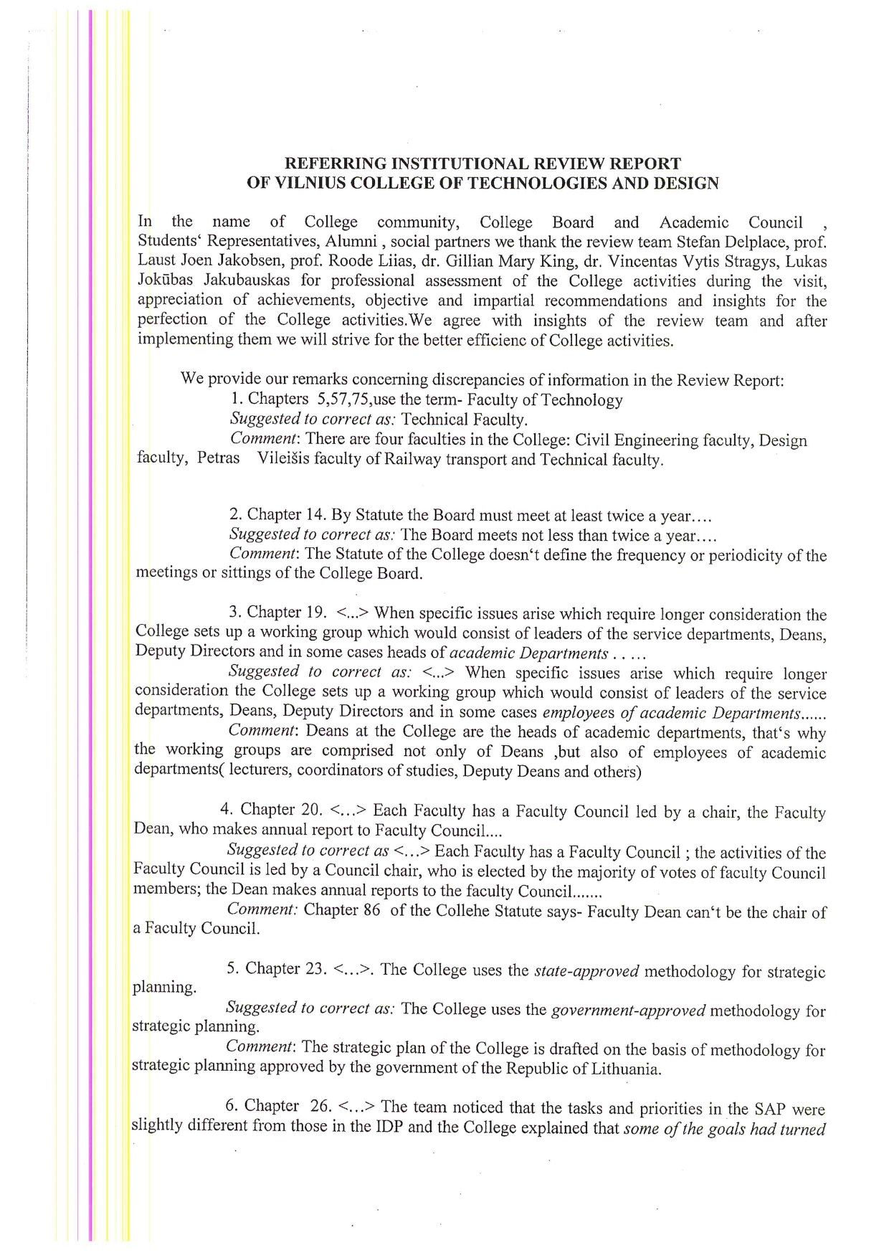

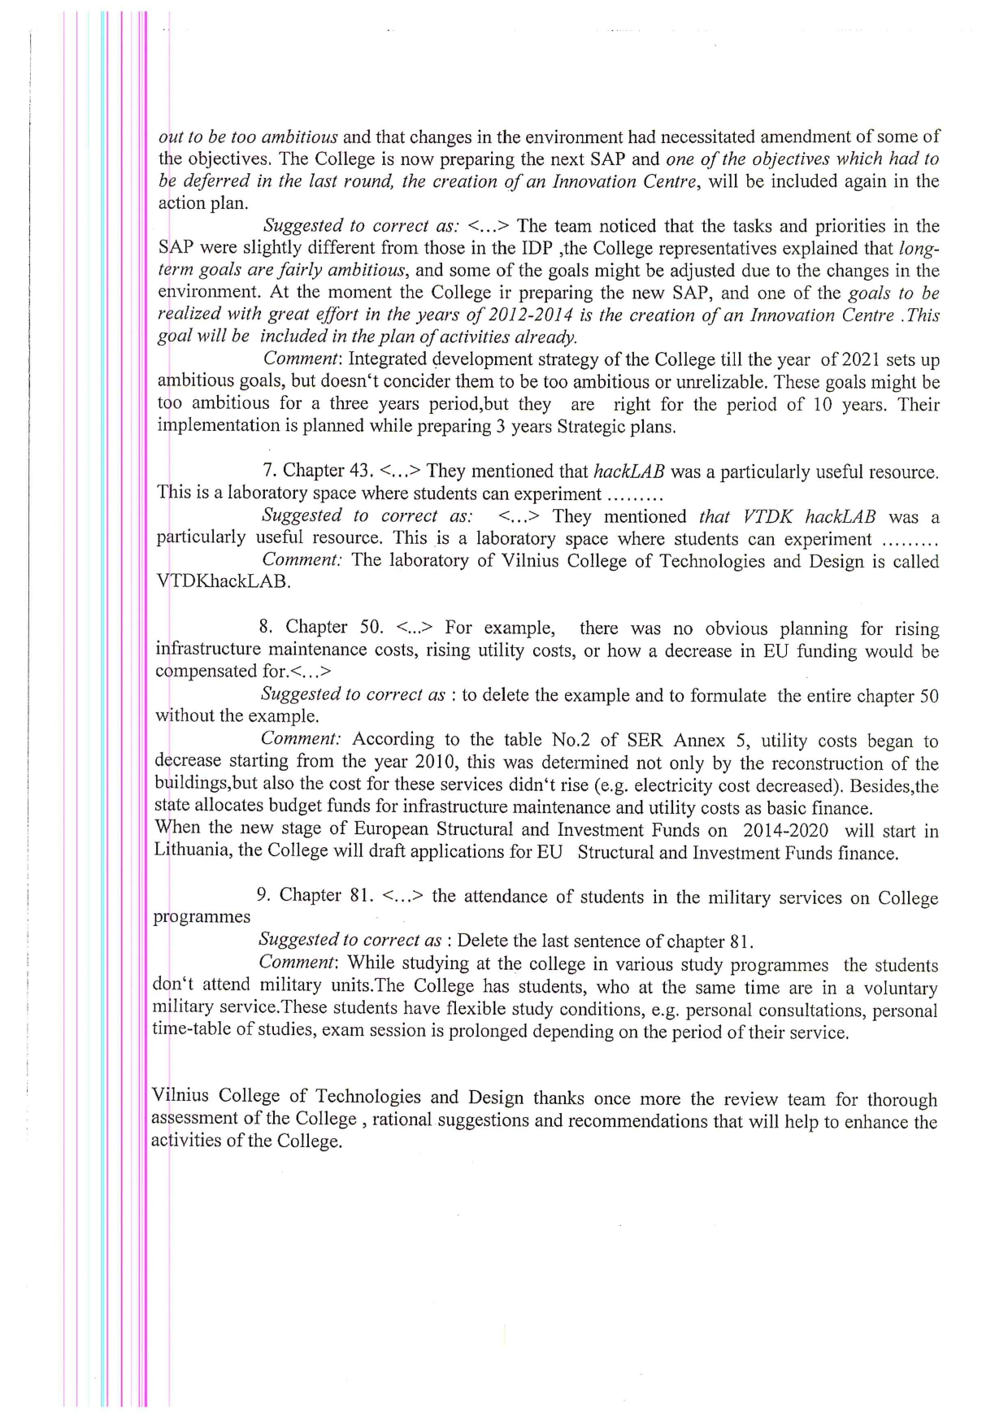

VTDK clarified in their feedback to the review report the lack of provision for rise of maintenance costs by stating that the utility costs began to decrease as from 2010. They also expressed their intention to apply for EU Structural and Investment funding, for the next round affecting Lithuania for the period 2014-2020.

